
SUN SAFE POLICY

Buddina State School
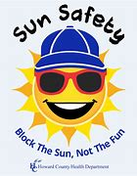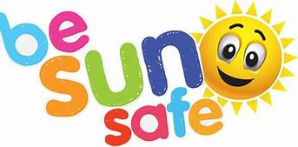

Queensland state schools play an important role in educating students about, and promoting the importance of, sun safe practices. Principals and staff of Buddina State have a duty of care to do what is reasonably practical to protect students and staff from the harmful effects of the sun caused by high ultraviolet radiation (UVR) exposure.
Queensland state schools aim to minimise staff and student exposure to UVR through the development and implementation of their own school-based sun safety policy, which includes a range of sun-safe strategies and addresses workplace health and safety requirements.
In Queensland, the UV Index is typically at damaging levels (that is usually above 3) during school hours all year. Reducing students’ sun exposure is the most effective way of reducing their risk of developing skin cancer later in life.
RATIONALE
Queensland has the highest rate of skin cancer in the world. Given students are at school during peak ultraviolet radiation times throughout the day, between 10am and 3pm, schools play a major role in both minimising a student’s UVR exposure and providing an environment where policies and procedures can positively influence student behaviour.
Skin damage, including skin cancer, is the result of cumulative exposure to the sun. Research shows severe sunburn contributes to skin cancer and other forms of skin damage such as sunspots, blemishes and premature aging. Most skin damage and skin cancer is therefore preventable.
Ultraviolet radiation (UVR) levels are highest during the hours students are at school. As students will spend a portion of their day outdoors, we are committed to protecting them from the harmful effects of the sun.
With that in mind, Buddina State School realises the need to protect students’ skin and educate them about Sun Safety behaviour, thus reducing the risk of skin damage from exposure to the sun.
IMPLEMENTATION
Responsibilities
Students are required to:
- wear protective clothing, including appropriate hats, when outdoors during the school day and school-related activities. Note: sun-safe hats are the preferred hat option.
- wear swim shirts/rash vests during all water-based activities at outdoor venues, except during their race/s at competitions and carnivals.
Principal (or delegate)
Is required to:
- supply an SPF 50 or higher broad-spectrum, water-resistant sunscreen for students to use on uncovered areas of the skin, such as the face and the back of the hands, for all outdoor activities.
- make the school’s sun safety policy publicly available on the school’s website
- implement the sun safety policy strategies during school and school-related activities.
- review the sun safety policy annually, and update as necessary.
- consider sun safe options from the school uniform Standing Offer Arrangement (DoE employees only) when determining or reviewing school uniform designs.

Parents and Citizens’ Associations (P&C)
Are required to:
- consider sun protection in relation to P&C activities and events held outdoors.

Education
- Parents are informed of the Buddina State School’s Sun Safety Policy when they enrol their student.
- The Sun Safety Policy is included on our School’s Facebook page and references made to Sun Safety in our school’s Handbook.
- We encourage our teachers to act as positive role models of Sun Safe behaviour.
Curriculum
- Incorporate sun protection and skin cancer prevention programs into the appropriate key learning areas of the school curriculum. Skin cancer awareness issues can be included in Health, Physical Education, or Science activities.
- Events and activities with a particular Sun Smart focus should be timetables to coincide with peak UV times.
- Professional development
- Teachers to have access to up-to-date information on skin cancer and its prevention. Current information is available by calling your Queensland Cancer Council.
- Queensland Cancer Council is available to offer curriculum and policy advice.
Uniform/Clothing 

- Students are required to wear the Buddina State School’s broad-brimmed hat during all recess break unless undercover and for all outdoor activities
- The students are to wear the correct uniform as outlined in the School Uniform Policy and that the current school uniform meets the Australian Standard AS4399:2020 for sun protective clothing (Australian Standard)?
- Staff are encouraged to wear broad-brimmed hats or a cap (or alternatively use a parasol/umbrella) for all outdoor activities, including playground duty.
- Free Dress Days will adhere to a Sun Safety clothing policy.
- Parents are encouraged to wear broad-brimmed hats, bucket hats or a cap (or alternatively use a parasol/umbrella) when participating in and attending outdoor school activities.
- Students are required to wear swim shirts/rash vests during all water-based activities occurring at outdoor venues, except during their race/s at competitions and carnivals
Sunscreen
- Students and staff are actively encouraged to apply SPF50 (or higher) broad-spectrum, water- resistant sunscreen regularly eg. prior to school, before lunch, PE lessons, sports carnivals and excursions.
- Sunscreen is easily available in each staffroom for staff and at the administration office or Physical Education staff room for student use.
- Sport and Physical Education
- Students are actively encouraged to wear the Buddina State School’s broad-brimmed hat for sport and physical education.
- The Buddina State School’s uniform should be worn for outdoor sporting events unless a specified uniform is to be worn.
- For outdoor swimming carnivals and swimming lessons, students are encouraged to wear a rash vest. The use of sunscreen SPF50 is encouraged and provided for staff, students and volunteers. Hats are required to be worn when not swimming.
- For athletic carnivals and excursions, students are required to wear shirts with sleeves; no singlets allowed. Hats are required and the use of SPF50 sunscreen encouraged and provided for staff, students and volunteers.
- Where possible, outdoor activities/events will be scheduled to minimise time in direct sun e.g. earlier in the morning or later in the afternoon. The use of indoor and shaded facilities will be considered at other times where possible.
- Physical Education teachers are required to wear a broad brimmed hat or a cap and encouraged to wear sun appropriate clothing.
- If the ambient temperature is between 31 and 35 degrees Celsius and the relative humidity is over 50%, there is a high to very high risk of heat illness. Planned vigorous, sustained physical activity should be limited in intensity or duration to less than 60 minutes per session.
- If the ambient temperature is over 36 degrees Celsius and the relative humidity is over 30%, there is an extreme risk of heat illness. Planned vigorous, sustained physical activity should be postponed to a cooler part of the day or even cancelled
- Camps and Excursions
- A risk assessment relating to sun exposure is conducted for the planning of outdoor activities and excursions.
Shade
- The Buddina State School Administration ensures shade provision is considered in plans for future buildings and grounds.
- Buddina State School ensures shade is available in the school’s grounds particularly in areas where students congregate – for example, lunch areas, canteen and outdoor lesson areas. If this is not possible, the school is working towards increasing and/or maintaining shade (built, portable or natural) in the school’s grounds.
- Where shade is otherwise not available, temporary shade structures are used for events such as sports carnivals.
- Students and staff are actively encouraged to use shade when outside, particularly if they are not wearing appropriate hat or clothing.

- Heatwave
- Immediate action
- Respond to warnings received from the radio or TV and local authorities.
- Contact Regional Office to notify of preparedness and any foreseen issues.
- Call together the site’s emergency response team to implement emergency procedures
- Link
https://education.qld.gov.au/student/Documents/excessive-heat-guidelines.docx
First Aid
What you can do to assist anyone needing first aid:
- In an Emergency, telephone triple zero (000) and get paramedics on the way immediately.
- Seek medical advice from your usual doctor, hospital or health clinic.
- Sit or lay the patient in a cool spot in the shade or under cover.
- Remove as much of the patient’s clothing as possible and loosen tight clothing.
- Cover them with a sheet soaked with tap water (NOT iced water).
- Use fans or air conditioning to aid the cooling down process.
- Give the patient water to drink, if they can swallow. MA

Symptoms of heat stress
- Symptoms of more severe heat stress include malaise, headache, rapid pulse, nausea and vomiting.
- People with heat stroke usually have core body temperatures above 39 degrees Celsius and an altered mental state such as confusion, lethargy or agitation. Seizures and coma can follow.
- See Department of Health Heat-related illness for more information.GEMENT

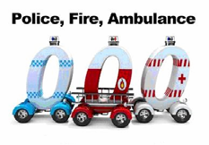
If the patient becomes unconscious then position them on their side in the recovery position whilst awaiting the ambulance.

Drink water regularly
- Facilitate and encourage students to drink plenty of water and to stay out of the sun.
- Drink 2 to 3 litres of water a day sipping at regular intervals, even if you do not feel thirsty. Sports drinks DO NOT replace water. If your fluid intake is limited on medical advice then check with your doctor on how much you should drink during hot weather.
- Avoid carbonated soft drinks and avoid tea and coffee as they worsen dehydration.
- Eat as you normally would but do try to eat cold foods, particularly salads and fruit which contain water.
- Avoid heavy protein foods (e.g. meat, dairy products, etc) which raise body heat and increase fluid loss.
- Drinks containing caffeine (tea, coffee, cola and some “energy” drinks) as well as drinks containing excessive sugar (soft drinks, colas, some “energy” and “sports” drinks) should be limited or avoided altogether.

Keep out of the heat
- Ensure that teachers modify or suspend normal school activities during excessive heat.
- Postpone any outdoor or sporting activities where appropriate except swimming, if it is not too far to walk – be mindful of the temperature of the water, which can heat up, especially if a pool blanket is used.
- Factors which need to be taken into account before considering cancelling or postponing a sporting event include but are not limited to:
- The duration and intensity of the event (for example, an endurance or distance event has more potential for problems than a stop-start team event)
- Hydration and interchange opportunities
- Time of day
- Local environment
- Acclimatisation of the participants (for example, students visiting from hot, dry climates may not cope well with hot, humid conditions of some northern, coastal regions)
- Fitness levels of participants
- Age and gender of participants.
- If you must go out then wear lightweight, light-coloured, loose, porous clothes, a wide-brimmed hat and sunscreen and regularly rest in the shade and drink fluids.
- If you can; avoid going out in the hottest part of the day (11am – 3pm).

- Stay cool
- Wear appropriate clothing to suit the hot weather.
- Increase access to the coolest areas of the school grounds or facilities for lessons or other activities e.g. breezeways
- Ensure students with special needs (including specific medical conditions and multiple impairments) are appropriately supervised, including the monitoring of their hydration.
- Ensure school lunch boxes are stored in cool areas.
- Block out the sun during the day by closing curtains and blinds and keep windows closed while the room is cooler than it is outside.
- Open up windows and doors when there is a cool breeze, when the temperature inside rises and at night for ventilation.
- Use fans and air-conditioners if possible.
- Splash yourself several times a day with cold water, particularly your face and the back of your neck
Occupational Health & Safety
- Consideration must be given to sun protection for all teachers involved in outdoor activities including playground duty.
- Physical Education teachers are at a high risk of UV exposure due to the amount of time spent outdoors and must take appropriate sun protection measures.
- The sun protection of all staff must be considered when developing a Sun Protection Policy.
- Skin cancer prevention strategies should be initiated and implemented through the school in the interests of student and staff health and in the development of a healthy school environment.
Environment
- Assess the use of the school grounds in relation to the availability and use of shade.
- Facilities/grounds committee to develop long term shade strategies for the school grounds.
- Shade-play equipment.
- Plant shade trees. Consider temporary shade structures as a short-term measure.
- Develop shade for high-risk areas such as canteens and assembly points.
Monitoring and evaluation plan
- Review the sun protective behaviour of students and staff.
- Continue to evaluate and update the skin cancer prevention component of the curriculum.
- Assess plans for future buildings and grounds with regard to shade provision.
- Review the effectiveness of sun protection strategies in your school and make recommendations for improvement if necessary.
Definitions

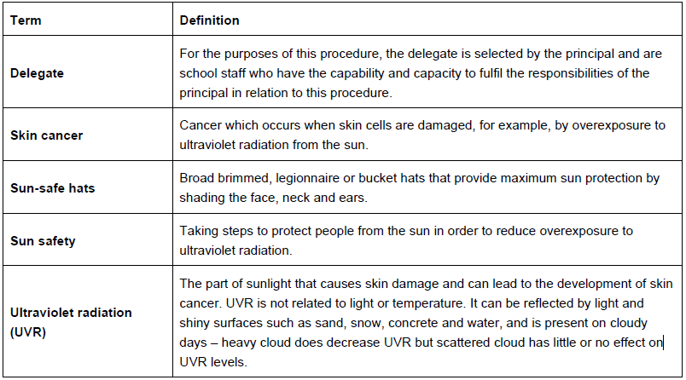
ANSWERS TO THE MOST COMMONLY ASKED SUN PROTECTION QUESTIONS
What is the best protection from harmful ultraviolet (UV) radiation?
The best protection from UV radiation is to put yourself in the shade, especially during the peak UV radiation times of the day. It is still important to apply SPF 50+ broad-spectrum sunscreen as UV reflects off most surfaces and therefore it is still possible to get burnt, even in the shade.
Why use Sunscreen?
Sever sunburn in childhood increases the risk of melanoma, the deadliest type of skin cancer, later in life. It has been estimated that if everyone used SPF 50+ broad-spectrum sunscreen regularly at least until the age of 18, the number of people getting melanoma could be reduced by over 70 per cent.
What is the best sunscreen to use?
While SPF 50+ broad-spectrum sunscreen is recommended by the Australian Cancer Society, SPF 30+ still provides very high protection.
When should zinc cream be used?
Zinc cream is a blockout providing a physical barrier that UV cannot penetrate. It can provide that extra degree of protection required for small sensitive areas such as the nose, lips and ears, particularly while swimming. Zinc cream is not appropriate for larger areas of skin as it does not allow the skin to breathe.
What is the best way to apply sunscreen?
Sunscreen should be used on areas not covered by clothing, such as the hands, forearms and face. Hats, clothing and shade provide better non-chemical protection and should be the first choice. Sunscreen should be applied liberally in an even thickness to clean, dry skin. Apply the sunscreen 15 to 30 minutes before going outside to allow time for it to interact and bond with the skin.
Should students wear sunglasses?
Long term exposure to the sun may promote eye damage. Consideration should be given to students wearing a hat and sunglasses when outside for any significant periods of time.
Identify sun protection measures that the area hasn’t already being undertaken
The following checklist can be used as a discussion document for improving sun protection at your school.
Sun Protection Strategy |  | x | How can we improve in this area?
100% of students wear either legionnaire or broad-brimmed hats.
No hat, play in the shade rule is implemented.
Teachers wear either legionnaire or broad- brimmed hats.
Parents are actively encouraged to wear hats when visiting the school.
Students are actively encouraged to use shaded areas.
All students eat lunch in full shade.
Sun protection and skin cancer awareness is incorporated in the curriculum at all year levels.
A plan is in place to increase/maintain the amount of shade at the school.
Where possible, outdoor activities are conducted outside peak UV times or held under cover
SPF 50+ sunscreen is available for staff and students whenever they go outside.
Students are encouraged to come to school wearing sunscreen.
The design of the school uniform provides good protection from the sun, eg, shirts with collars, longer sleeves.
Students attending outdoor swimming classes are required to wear T-shirts, rash-vests or swimwear which fully covers their trunk.
There are regular sun protection reminders.
Sun protection is incorporated into the planning of all outdoor events.
- REFLECTION MATERIAL
- Cancer Council Australia Sun Protection Information
- Queensland Government – Sun Safety Guidelines for Qld Schools and Committee
- Becoming a SunSmart School tells the community that your school is committed to the future health of its students.
- 